IN THE UNITED STATES DISTRICT COURT
EASTERN DISTRICT OF WISCONSIN

KEEFE JOHN and JORGE HUTCHINGS, on behalf of themselves and all others similarly situated,  Plaintiffs,  v.  DELTA DEFENSE, LLC and United States Concealed Carry Association, Inc.,  Defendants. | Case No. 23-cv-01253  JURY TRIAL DEMANDED  FIRST AMENDED CLASS ACTION COMPLAINT FOR VIOLATIONS OF the Video Privacy Protection Act, 18 U.S.C. § 2710

FIRST AMENDED CLASS ACTION COMPLAINT
Plaintiffs Keefe John and Jorge Hutchings (“Plaintiffs”) bring this class action lawsuit in their individual capacities and on behalf of all others similarly situated against Delta Defense, LLC (“Delta Defense”) and the United States Concealed Carry Association, Inc. (“USCCA” and with Delta Defense, “Defendants”) and allege, upon personal knowledge as to their own actions, their counsel’s investigation and upon information and good faith belief as to all other matters, as follows:

INTRODUCTION
- This is a consumer privacy class action lawsuit against Delta Defense and the USCCA for disclosing their digital subscribers’ identities and video-viewing preferences— without their consent—to Meta Platforms Inc. (“Meta”), which owns the social networking website and app Facebook, in violation of the Video Privacy Protection Act, 18 U.S.C. § 2710 (the “VPPA” or “the Act”).
- Operating through Delta Defense, the USCCA is a membership-based organization that aggressively markets and sells access to videos that provide “three tiers of education and legal protection.” As detailed herein, those tiers are sold at increasing price points and give purchasers greater access to digital videos about various gun-related topics.
- On their Website www.usconcealedcarry.com (the “Website”), Defendants offer a vast array of video content; for instance, when a user navigates to the webpage https://academy.usconcealedcarry.com/videos, they are required to create an account in order to view any video; that account creation page requires the user to provide personal identifying information including (i) first name, (ii) last name, (iii) email, and (iv) mobile phone (collectively, “Personal Information” or “PII”). That is, in order to stream videos, Plaintiffs first had to provide both personal information and pay the membership fee.
- As detailed herein, Defendants made the decision to employ tracking technologies (namely, pixels) to collect and to share with third parties, such as Facebook, the viewing information of its subscribers without obtaining informed, stand-alone consent as is required by the VPPA.
- In so doing, Defendants violate the VPPA, which prohibits “video tape service providers,” such as Defendants, from knowingly disclosing consumers’ PII, including “information which identifies a person as having requested or obtained specific video materials or services from a video tape provider,” unless the consumer expressly consented to the disclosures in a standalone consent form. Accordingly, Plaintiffs, on behalf of a class of similarly situated users, assert a claim for violations of the VPPA and seek all appropriate relief including, but not limited to, statutory damages in an amount not less than $2,500 for each disclosure of PII, punitive damages and attorneys’ fees and costs.

PARTIES
- Plaintiff Keefe John is a citizen and resident of Jackson, Wisconsin, where he has resided at all times relevant hereto. Plaintiff John intends to reside in Jackson, Wisconsin indefinitely.
- Plaintiff Jorge Hutchings is a citizen and resident of Indianapolis, Indiana, where he has resided at all times relevant hereto. Plaintiff Hutchings intends to reside in Indianapolis, Indiana indefinitely.
- Plaintiffs John and Hutchings used their internet-connected devices and web-browsing software installed on those devices to visit and to watch video content on Defendants’ Website during the Class Period.
- Defendant Delta Defense is a Wisconsin Limited Liability Company with a business address of 1000 Freedom Way in West Bend, Wisconsin 53095-4945. Delta Defense is the operating company of the USCCA, and provides sales, marketing, operations and administrative support services to the USCCA and is a licensed insurance agency in all fifty states and the District of Columbia.
- USCCA is a State of South Carolina non-profit corporation with a principal place of business address at 38 Broad Street, Suite 200 in Charleston, South Carolina 29401.

JURISDICTION & VENUE
- This Court has original jurisdiction under 28 U.S.C. § 1331 based on Plaintiffs’ claims under the Video Privacy Protection Act, 18 U.S.C. § 2710.
- This Court also has jurisdiction over this lawsuit under the Class Action Fairness Act, 28 U.S.C. § 1332(d)(2) (“CAFA”) because this lawsuit is a proposed class action in which: (i) there are at least 100 Class members; (ii) the combined claims of class members exceed $5,000,000, exclusive of interest, attorneys’ fees and costs and (iii) Defendants and at least one class member are domiciled in different states.
- This Court has personal jurisdiction over Defendants because (i) Delta Defense has its principal place of business within this District and (ii) they have sufficient minimum contacts in Wisconsin to render the exercise of jurisdiction by this Court proper and necessary.
- Venue is proper in this judicial district under 28 U.S.C. § 1391(b) because a substantial part of the events or omissions giving rise to Plaintiffs’ claims occurred in this District, and Delta Defense’s principal place of business is located here, and both Defendants have considerable business presence in this judicial district.

COMMON FACTUAL ALLEGATIONS

  - Defendants’ Business & Membership Tiers
- Delta Defense is in the business of sales and marketing of self-defense education and firearms training videos to potential members of the USCCA.
- The USCCA, through its operating company Delta Defense, is a membership-based organization which offer “three tiers of education and legal protection” through various videos accessible on their Website:

- Defendants’ lowest priced membership option is their “Gold tier,” which is sold for $29.00 per month, or $299.00 for an annual membership.
- Consumers who purchase the Gold tier membership option receive, among other things, more than fifty-three (53) video series episodes.
- Defendants describe their membership services as “just like your favorite streaming service, but with hundreds of self-defense and firearms training videos on demand like When to Use Deadly Force and Situational Awareness.”
- Defendants’ “Platinum tier” is marketed and sold for $39.00 per month or $399.00 for an annual membership and includes all of the items contained in the Gold tier, but the number of video series episodes is increased from 53 to more than 145.
- The Platinum tier also includes additional video content such as its “Ask an Attorney” video series described as “the most important self-defense questions answered by an award-winning criminal defense attorney.”
- Defendants’ most comprehensive (and expensive) membership option is their “Elite tier,” which is sold for $49.00 per month or $499.00 for an annual membership and increases the number of video series episodes from 145 (in the Platinum tier) to more than 318.
- Like the Platinum tier, the Elite tier includes additional video content, such as its “Ask an Attorney” video series and it also provides access to the “Ask an Attorney” complete archive which is marketed as “access to all the past ‘Ask an Attorney’ videos to increase your legal preparation.”
- Defendants try to create a false sense of urgency to compel visitors to the Website to sign up and to pay for a membership:

- On information and good faith belief, the “offer” does not end soon or, frankly, ever.
- Defendants offer a vast array of video content; when a user navigates to the Website, they are presented with the option to “Join” by creating an account under one of the membership options.
- The account creation page requires the user to provide a considerable amount of personal identifying information including (i) first name, (ii) last name, (iii) address, (iv) email and (v) mobile phone.
- Defendants state that there are at least 788,623 members and Tim Schmidt, USCCA’s Chairman & Co-Founder, has publicly stated his intention to achieve 1,000,000 members in the near term.
B. Defendants Use Pixels to Transmit Users’ Video Viewing Histories to Facebook
- Once a consumer, such as Plaintiffs, creates an account with the USCCA by providing PII and paying the membership fee, they are then able to view prerecorded audiovisual content from Defendants.
- While Plaintiffs and Class members were viewing prerecorded video content on Defendants’ Website, Defendants transmitted their viewing choices to Meta.
- Defendants’ transmission of viewing information to Meta included the specific names of video content viewed by users as well as the user’s unique Facebook ID (“FID”), a string of numbers unique to each Facebook profile that personally identifies the user.
- Just as Meta can easily identify any individual on its Facebook platform with only their unique FID so too can any ordinary person who comes into possession of an FID. Facebook admits as much on its website.
- For example, when a video is accessed on Defendants’ Website, the name and viewer’s FID, which is represented by the “c_user” cookie, are sent to Meta.
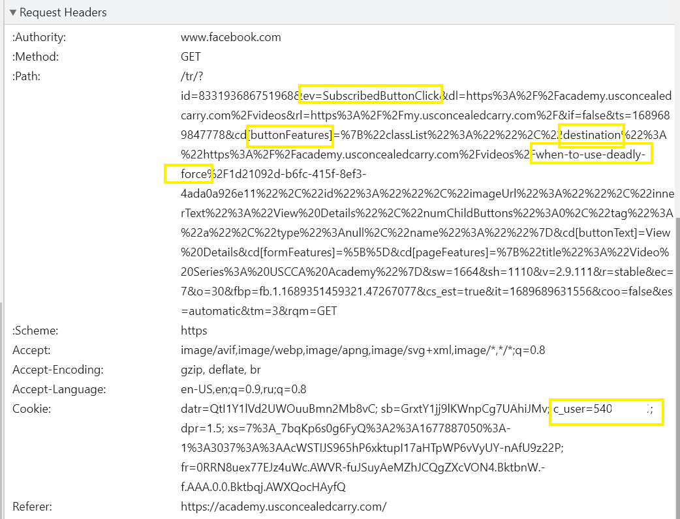
- For example, if a subscriber clicks on one of the videos, such as “When to Use Deadly Force,” that event gets shares with Facebook, along with the user’s FID in the c_user cookie value which links the user to their unique Facebook account:
- Additionally, Defendants track every step of users’ activity on their Website.
- As an example, if a user stops watching a video but comes back to resume it, Defendants track that as well, by capturing the inner text of the buttons the user is clicking:
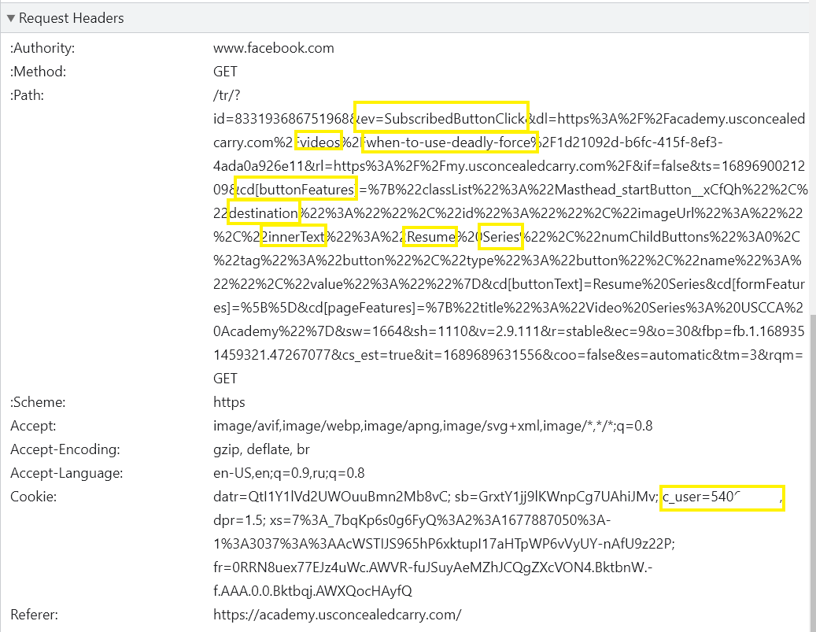
- Thus, equipped with an FID and the video content name and URL—all of which Defendants knowingly provide to Meta without necessary standalone consent from its subscribers—any ordinary person could determine the identity of Defendants’ subscribers and the specific video or media content they viewed on Defendants’ Website.
- Defendants transmit the FID and video titles to Meta in a single transmission, through an invisible tracking tool called a “Meta Pixel.”
- A Meta Pixel is a snippet of a programming code that—once installed on a webpage—sends information to Meta. This transmission occurs when a user views a prerecorded video on Defendants’ Website.
- The Pixel is an advertising tool that allows website owners to track visitor actions on their websites for purposes of sending the corresponding information to Meta; websites use the Pixel in hopes of better targeting their products and services on Facebook to interested consumers.
- Thus, a business such as Defendants chooses to install the Pixel on its Website to increase its profits.
- According to Meta, the Pixel allows it “to match your website visitors to their respective Facebook User accounts” and that “[o]nce matched, we can tally their actions in the Facebook Ads Manager so you can use the data to analyze your website’s conversion flows and optimize your ad campaigns.”
- Defendants knew that by installing the Pixel on their Website, the Pixel would send Meta information identifying its users and their video-watching habits.
- Meta explains that, to begin using the Meta Pixel, a business must first “install” the Pixel “by placing the Meta Pixel base code on all pages of your website[.]”
- Defendants, therefore, made a conscious and intentional choice to install the Pixel on their Website to share their subscribers’ video viewing histories with Meta for marketing purposes in violation of the VPPA and Wisconsin state law.
- Further demonstrating that Defendants knowingly placed the Pixel in their Website code, Meta’s website states that “[d]evelopers and marketers can optionally choose to send information about” a visitor’s activity on its website.
- Meta benefits from websites like Defendants installing its Pixel; when the Pixel is installed on a business’s website, the business has a greater incentive to advertise through Facebook and/or other Meta-owned platforms like Instagram.
- In addition, even if the business does not advertise with Facebook, the Pixel assists Meta in building more fulsome profiles of its own users, which in turn allows Meta to profit from providing more targeted ads.
- Using the Meta Pixel likewise benefits Defendants’ business by improving its ability to promote its content and services to its users.
- Through use of the Meta Pixel, Defendants disclose to Meta the full name of each video a user watched, together with the user’s FID, thus linking users’ viewing content choices and preferences to their Facebook profiles.
- Defendants violate and invade the privacy rights of users with their practice of sending their users’ FIDs, together with their viewing content, to Meta.
- Plaintiffs and Class members neither knew of nor authorized or otherwise consented to, Defendants’ disclosure of their prerecorded video and video-services requests and their identities to Meta.
- As a result, Defendants violate the VPPA by disclosing this information to Meta.
C. Defendants Do Not Disclose Their Use of the Meta Pixel
- The VPPA requires that consent be obtained in a form “distinct and separate from any form setting forth other legal or financial obligations of the consumer.” 18 U.S.C. § 2710.
- At no point were Plaintiffs provided a standalone consent form disclosing Defendants’ practices at issue and requesting user consent.
- Hence, no user knew of or consented to Defendants’ offending practice of sharing video preferences with third parties.
D. Plaintiffs & the Class Were Harmed by Defendants’ Privacy Invasions.
- Defendants shared with Meta the PII of Plaintiffs and Class members, including their video viewing histories and associated FIDs, which they reasonably expected would be kept private.
- The PII Defendants obtained from Plaintiffs and Class members constitutes valuable data in the digital advertising-related market for consumer information.
- Defendants’ wrongful acquisition and use of their PII deprived Plaintiffs and Class members of control over that information and prevented them from realizing its full value for themselves.
- Defendants’ conduct caused economic harm to Plaintiffs and Class members whose PII diminished in value when Defendants made this information available to Meta.
- The harms described above are aggravated by Defendants’ continued retention and commercial use of Plaintiffs’ and Class members’ PII, including their private video viewing histories.
- The relationship between Plaintiffs and other subscribers to Defendants was and continues to be substantial in that it involved creating a paid account, which committed subscribers to an ongoing, financial relationship with Defendants.
- The subscribers’ status as paid users was a necessary condition for accessing the videos on the Website. On information and good faith belief, non-subscribers were prohibited from viewing the videos as that benefit was reserved for paid subscribers.
- The subscribers actively provided PII and money in exchange for a subscription to specific, otherwise restricted video content, which Defendants provided in an ongoing and recurrent fashion, as defined by the various membership tiers. Subscribers paid, registered, committed and associated with Defendants in exchange for the delivery of and access to restricted video content.

REPRESENTATIVE PLAINTIFFS’ ALLEGATIONS

Plaintiff Keefe John
- Plaintiff John is a Gold Tier subscriber to Defendants’ membership services and a Facebook user.
- Plaintiff John has maintained a USCCA membership and account since at least July 2023 and is thus a subscriber to Defendants’ services.
- Plaintiff John provided Defendants with his PII, including at least his first and last name, email address and mobile phone number, when subscribing to their services.
- Plaintiff John’s Facebook profile includes his name and other personal details.
- Plaintiff John watches prerecorded video content on Defendants’ Website regularly.
- Plaintiff John visited Defendants’ Website to request and watch prerecorded video content using the same browser that he uses to log in to Facebook, including while he was logged in to Facebook.
- Plaintiff John also uses the same device to request and watch prerecorded videos on Defendants’ Website that he uses for Facebook.
- Plaintiff John has been served targeted advertisements announcing the commercial availability of Defendants’ goods and services on Facebook after watching related videos on their Website.
Plaintiff Jorge Hutchings
- Plaintiff Hutchings is an elite tier subscriber to Defendants’ membership services and a Facebook user.
- Plaintiff Hutchings has maintained a USCCA membership and account since at least March 2022 and is thus a subscriber to Defendants’ services.
- Plaintiff Hutchings provided Defendants with his PII, including at least his first and last name, address, email address and mobile phone number, when subscribing to their services.
- Plaintiff Hutchings’ Facebook profile includes his name and other personal details.
- Plaintiff Hutchings watches prerecorded video content on Defendants’ Website monthly.
- Plaintiff Hutchings visited Defendants’ Website to request and watch prerecorded video content using the same browser that he uses to log in to Facebook, including while he was logged in to Facebook.
- Plaintiff Hutchings also uses the same device to request and watch prerecorded videos on Defendants’ Website that he uses for Facebook.
- Plaintiff Hutchings has been served targeted advertisements announcing the commercial availability of Defendants’ goods and services, specifically of USCCA membership services, on Facebook after watching related videos on their Website.

CLASS ACTION ALLEGATIONS

- Plaintiffs bring this lawsuit under Federal Rules of Civil Procedure 23(a), (b)(1), (b)(2), and (b)(3), and/or (c)(4) as representatives of the Class preliminarily defined as:
Nationwide Class: All persons in the United States who have a Facebook account, subscribed to Defendants’ Website and viewed prerecorded video content on Defendants’ Website during the time Meta’s Pixel was active on Defendants’ Website.

- Excluded from the Class are Defendants, its employees, agents and assigns, and any members of the judiciary to whom this case is assigned, their respective court staff, the members of their immediate families, and Plaintiffs’ counsel.
- Plaintiffs reserve the right to modify, change or expand the Class definition based upon discovery and further investigation.
- Numerosity: The Class consists of hundreds of thousands of individuals making joinder wholly impractical.
- Commonality and Predominance: Common questions of law and fact exist with regard to each of the claims and predominate over questions affecting only individual Class members. Questions common to the Class include:
- Whether Defendants’ use of the Meta Pixel to capture and to disclose Plaintiffs’ and Class Members’ video viewing history was without user consent and authorization;

- Whether Defendants obtained and shared or caused to be obtained and shared Plaintiffs’ and Class members’ PII through tracking using Meta Pixel, which Defendants installed on their webpages;

- Whether Defendants’ conduct violates the Video Privacy Protection Act, 18 U.S.C. § 2710, et seq.;

- Whether Defendants’ acquisition and transmission of Plaintiffs’ and Class members’ PII resulted in harm and

- Whether Defendants should be enjoined from engaging in such conduct in the future.

- Typicality: Plaintiffs’ claims are typical of the claims of the Class members in that Plaintiff, like all Class members, has been injured by Defendants’ misconduct at issue—i.e., disclosing users’ PII and viewing content to Meta without appropriate consent.
- Adequacy of Representation: Plaintiffs will fairly and adequately represent and protect the interests of the Class. Plaintiffs have retained counsel with substantial experience in prosecuting complex litigation and class actions, including privacy protection cases. Plaintiffs do not have any interests antagonistic to those of the Class.
- Superiority: A class action is superior to other available methods for the fair and efficient adjudication of this controversy. Class-wide damages are essential to induce Defendants to comply with applicable law. Moreover, because the amount of each individual Class member’s
claim is small relative to the complexity of the litigation, and because of Defendants’ financial resources, Class members are unlikely to pursue legal redress individually for the violations detailed in this Complaint. A class action will allow these claims to be heard where they would otherwise go unheard because of the expense of bringing individual lawsuits, and provides the benefits of adjudication, economies of scale, and comprehensive supervision by a single court.
- Injunctive relief: Defendants have acted or refused to act on grounds generally applicable to the Class, thereby making appropriate final injunctive relief and corresponding declaratory relief with respect to the class as a whole.

TOLLING OF THE STATUTE OF LIMITATIONS

- All applicable statute(s) of limitations have been tolled by Defendants’ knowing and active concealment of the facts alleged herein. Plaintiffs and Class members could not have reasonably discovered Defendants’ practices of sharing their personal viewing content and PII with Meta until shortly before this class action litigation commenced.
- Defendants were and remain under a continuing duty to disclose to Plaintiffs and Class members their practice of sharing personal viewing content and PII to Meta. As a result of the active concealment by Defendants, any applicable statutes of limitations otherwise applicable to the allegations herein have been tolled.

FIRST CAUSE OF ACTION

Violation of the Video Privacy Protection Act (the “VPPA”)

18 U.S.C. § 2710, et seq.
(On Behalf of the Nationwide Class)

- Plaintiffs incorporate and reallege the above factual allegations by reference.
- The VPPA prohibits a “video tape service provider” from knowingly disclosing “personally-identifying information” concerning any consumer to a third party without the “informed, written consent (including through an electronic means using the Internet) of the consumer.” 18 U.S.C. § 2710.
- As defined in 18 U.S.C. § 2710(a)(4), a “video tape service provider” is “any person, engaged in the business, in or affecting interstate commerce, of rental, sale, or delivery of prerecorded video cassette tapes or similar audiovisual materials.”
- Defendants are “video tape service providers” as defined in 18 U.S.C. § 2710(a)(4) because they engaged in the business of delivering audiovisual materials—including the prerecorded videos that Plaintiffs viewed—through their online platform that are similar to prerecorded video cassette tapes and those deliveries affect interstate or foreign commerce. Defendants are substantially involved in the conveyance of video content to consumers, profit specifically from that conveyance and Defendants’ business is significantly tailored to serve that purpose.
- As defined in 18 U.S.C. § 2710(a)(3), “personally identifiable information” is defined to include “information which identifies a person as having requested or obtained specific video materials or services from a video tape service provider.”
- Defendants knowingly caused personal viewing information, including FIDs, concerning Plaintiffs and Class members, to be disclosed to Meta.
- This information constitutes personally identifiable information under 18 U.S.C. § 2710(a)(3) because it identified each Plaintiff and Class member to Meta as an individual who viewed Defendants’ video content, including the specific prerecorded video materials each such individual watched on Defendants’ Website.
- This information allowed Meta to identify Plaintiffs and Class members’ specific individual video- viewing preferences and habits.
- As defined in 18 U.S.C. § 2710(a)(1), a “consumer” means “any renter, purchaser, or subscriber of goods or services from a video tape service provider.” As alleged above, Plaintiffs are subscribers to Defendants’ services, which provide video content to users on their Website, and viewed prerecorded videos provided on Defendants’ platform. Hence, Plaintiffs are “consumers” under this definition.
- As set forth in 18 U.S.C. § 2710(b)(2)(B), “informed, written consent” must be (1) in a form distinct and separate from any form setting forth other legal or financial obligations of the consumer; and (2) at the election of the consumer, is either given at the time the disclosure is sought or is given in advance for a set period of time not to exceed two years or until consent is withdrawn by the consumer, whichever is sooner.
- Defendants failed to obtain informed, written consent under this definition.
- Additionally, the VPPA creates an opt-out right for consumers in 18 U.S.C. § 2710(b)(2)(B)(iii).
- The Act requires video tape service providers to “provide[] an opportunity, in a clear and conspicuous manner, for the consumer to withdraw on a case-by-case basis or to withdraw from ongoing disclosures, at the consumer’s election.”
- Defendants failed to provide an opportunity to opt out as required by the Act.
- Defendants were aware that the disclosures to Meta that were shared through the Pixel identified Plaintiffs and Class members. Defendants also knew that Plaintiffs’ and Class members’ personal viewing content was disclosed to Meta because Defendants programmed the Meta Pixel into their Website code, knowing that Meta would receive video titles and the subscriber’s FID when a user watched a prerecorded video.
- By knowingly disclosing Plaintiffs’ and Class members’ personal viewing content, Defendants violated Plaintiffs’ and Class members’ statutorily protected right to privacy in their prerecorded video-watching habits. See 18 U.S.C. § 2710(c).
- As a result of the above violations, Defendants are liable to Plaintiffs and Class members for actual damages related to their loss of privacy in an amount to be determined at trial or, alternatively, for “liquidated damages not less than $2,500 per plaintiff.” 18 U.S.C. § 2710(c)(2)(A).
- Under the Act, Defendants are also liable for reasonable attorney’s fees, other litigation costs, injunctive and declaratory relief, and punitive damages in an amount to be determined by a jury and sufficient to prevent and deter the same or similar conduct by Defendants in the future.

PRAYER FOR RELIEF

WHEREFORE, Plaintiffs, individually and on behalf of all others similarly situated, respectfully request that this Honorable Court enter judgment in their favor and against Delta Defense, LLC and the United States Concealed Carry Association, Inc. as follows:
- Certify this case as a class action, and appoint Plaintiffs as Class Representatives and the undersigned attorneys as Class Counsel;

- Enter judgment in favor of Plaintiffs and the Class;

- Enter injunctive and/or declaratory relief as is necessary to protect the interests of Plaintiffs and Class members, including reformation of practices and an accounting and purging of wrongfully obtained personal information;

- Award all actual, general, special, incidental, statutory, treble, punitive, liquidated, and consequential damages and/or restitution to which Plaintiffs and Class members are entitled;

- Award disgorgement of monies obtained through and as a result of the wrongful conduct alleged herein;

- Award Plaintiffs and Class members pre- and post-judgment interest as provided by law;

- Enter such other orders as may be necessary to restore to Plaintiffs and Class members any money and property acquired by Defendants through their wrongful conduct;

- Award Plaintiffs and Class members reasonable litigation expenses and attorneys’ fees as permitted by law and

- Award such other and further relief as the Court deems necessary and appropriate.

DEMAND FOR JURY TRIAL

Pursuant to Federal Rule of Civil Procedure 38(b), Plaintiffs hereby demand a trial by jury of all issues triable as of right.
Dated: February 13, 2023 Respectfully submitted,

HANSEN REYNOLDS LLC

/s/ Timothy M. Hansen
Timothy M. Hansen (SBN 1044430)
Michael C. Lueder (SBN 1039954)
301 N. Broadway, Suite 400
Milwaukee, Wisconsin 53202
(414) 455-7676 (phone)
(414) 273-8476 (fax)
thansen@hansenreynolds.com
mlueder@hansenreynolds.com

/s/ David S. Almeida
ALMEIDA LAW GROUP LLC
David S. Almeida (WI Bar # 1086050)
849 W. Webster Avenue
Chicago, Illinois 60614
Phone: 312-576-3024
david@almeidalawgroup.com

Attorneys for Plaintiffs & the Class

https://www.usconcealedcarry.com/about/ (last visited February 13, 2024).
https://www.usconcealedcarry.com/ (last visited February 13, 2024).
https://www.facebook.com/help/211813265517027 (last visited February 13, 2024).
The “c_user” cookie that is transmitted contains the viewer’s unencrypted FID.
https://developers.facebook.com/docs/meta-pixel/get-started/ (last visited February 13, 2024).
https://www.facebook.com/business/help/952192354843755?id=1205376682832142 (last visited February 13, 2024).
https://developers.facebook.com/docs/meta-pixel/ (last visited February 13, 2024).
In other words, this single transmission connects a user’s video content with their FID.

